When I first started this project it was decided that the most urgent need was to install additional playground equipment to the current existing structure. I was told students were standing in long lines at recess because of the lack of adequate equipment. I was also told 4th and 5th grade students were not allowed on the current equipment due to the shortage of available play space. So my original goal was to keep the current structure but install additional equipment to meet this immediate need. The cost to accomplish this was $55,000 for the equipment and required materials. Here is a picture of the original planned structure:

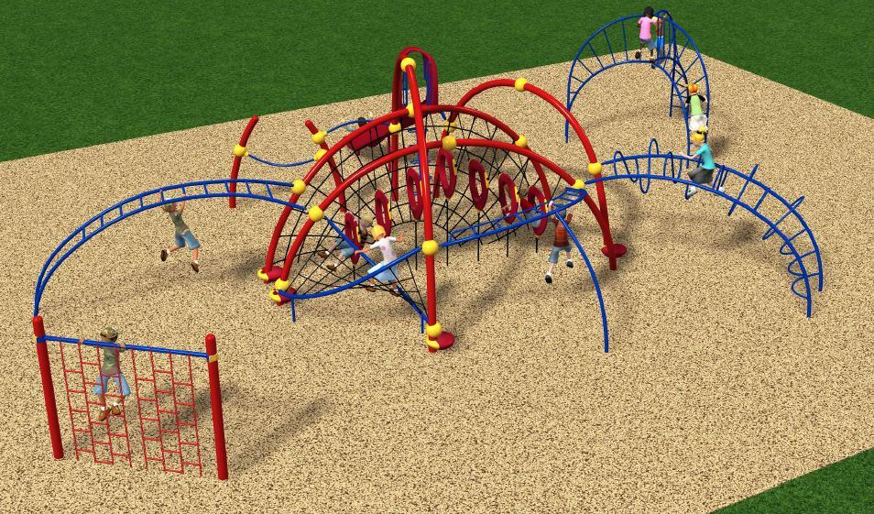

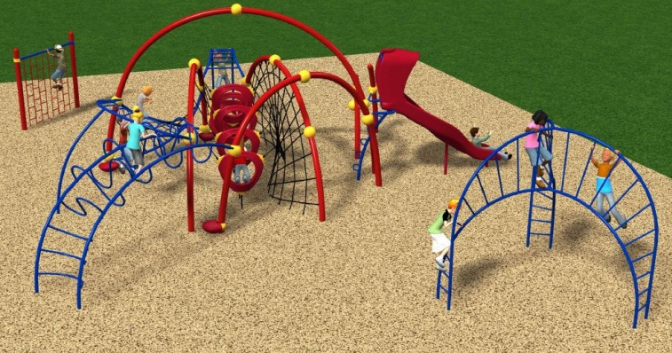

I did recently exceed this original goal, but decided to try to fundraise enough funds to replace the current aging equipment. After doing some research we found the existing equipment will become too costly for the district to maintain within a few short years and will likely need to be removed. We have also decided to install an additional set of swings for the amount of $4600. We are keeping Jefferson current swings as they are only a few year old. Here is a picture of how the new swings will look:

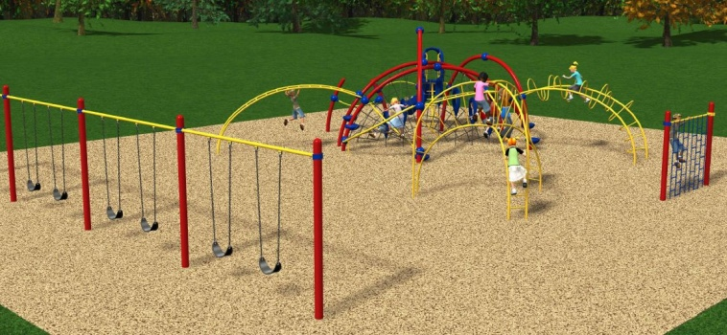

We have three options in mind to replace the existing structure:

Option 1

Total project cost - $90,371.00
Amount remaining to raise - $21,518.09
This will give Jefferson the most complete replacement of existing equipment.

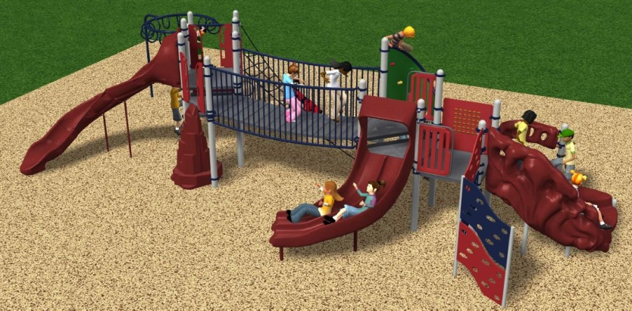

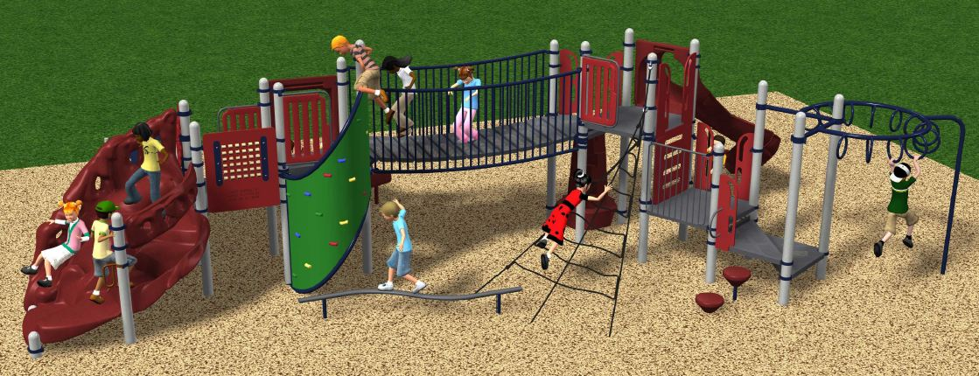

Option 2

Total project cost - $83775.00
Amount remaining to raise - $14,922,09

This will give Jefferson a very nice new playground set with some room to add additional pieces if desired in the future.

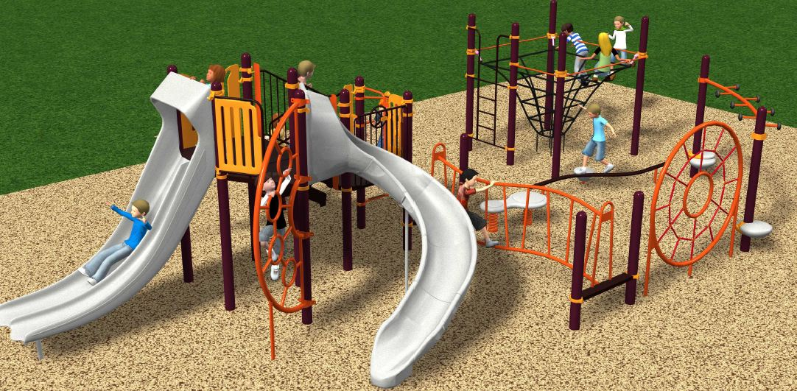

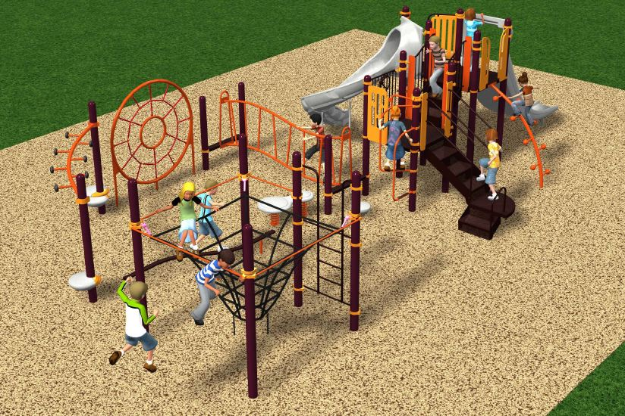

Option 3

Total project cost - $74,315.00
Amount remaining to raise - $5,462.09

This will give Jefferson a nice new structure and allow the PTA to add additional pieces in the future as funds are available.

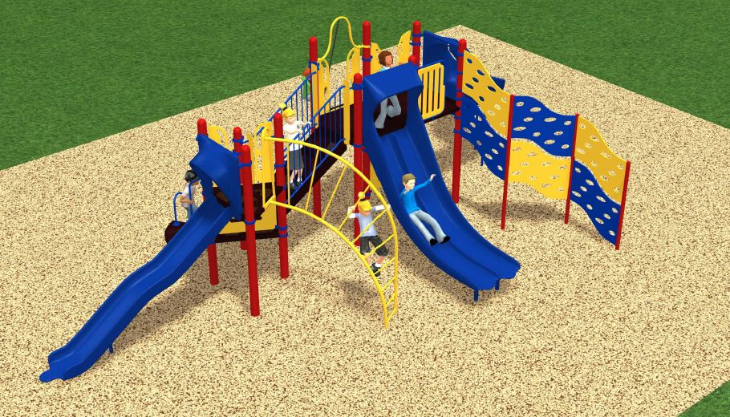

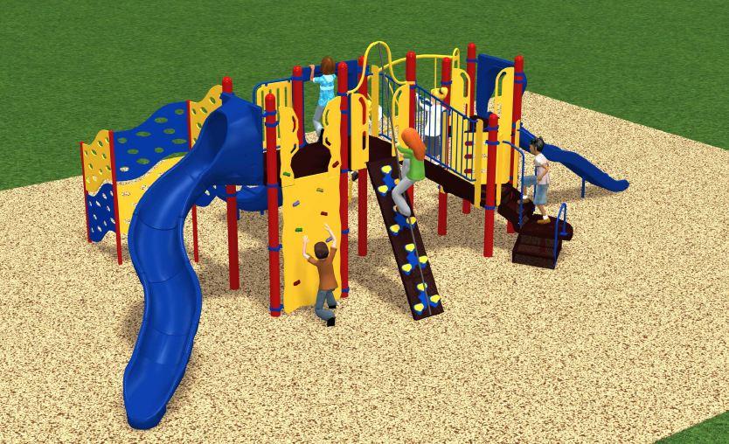

Finally here is an example of how the entire playground will look with the old structure replaced. Option 2 is pictured just for an example.

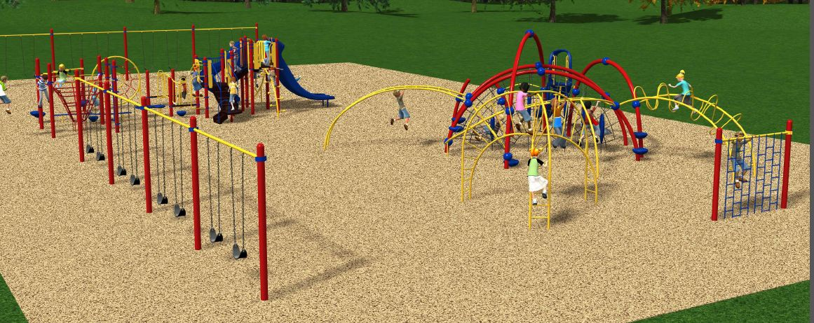

If for some reason we are not able to raise the necessary funds to complete at least Option 3 we will use the funds available to install other additional equipment and keep the current structure.

Keep in mind these the options presented here at this point represent ideas I have to establish fundraising goals. Ultimately the replacement structure will be determined by the amount funds we raise and what the Jefferson staff determines as appropriate for their students.

